C:\Users\user\Desktop\PGDB-2022\PRADIP\ACTREC work\02.11.2022\Truncated_OS.tiff

Overall Survival rate:

|  |  |  |  |
| --- | --- | --- | --- |
|  | survival rate | lower 95% CI | upper 95% CI |
| truncatedOS 3 year survival rate | 0.777 | 0.0259 | 0.728 |
| truncatedOS 5 year survival rate | 0.707 | 0.649 | 0.771 |

Overall Survival groupwise rate:

|  |  |  |  |  |
| --- | --- | --- | --- | --- |
|  |  | survival rate | lower 95% CI | upper 95% CI |
| truncatedOS 3 year survival rate | GTR+NTR | 0.7882 | 0.7332 | 0.8473 |
|  | STR | 0.7331 | 0.6283 | 0.8554 |
| truncatedOS 5 year survival rate | GTR+NTR | 0.7406 | 0.6782 | 0.8087 |
|  | STR | 0.58 | 0.447 | 0.752 |

**Hazard Ratio Table:**

**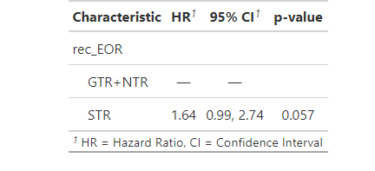**



The Median is not achieved.

|  |  |  |  |  |
| --- | --- | --- | --- | --- |
|  |  | survival rate | lower 95% CI | upper 95% CI |
| truncatedOS 3 year survival rate | WNT | 0.916 | 0.8404 | 0.9984 |
|  | SHH | 0.784 | 0.706 | 0.871 |
|  | group3 | 0.6192 | 0.4889 | 0.7842 |
|  | group4 | 0.7729 | 0.6815 | 0.8765 |
|  |  | survival rate | lower 95% CI | upper 95% CI |
| truncatedOS 5 year survival rate | WNT | 0.916 | 0.8404 | 0.9984 |
|  | SHH | 0.6574 | 0.5591 | 0.773 |
|  | group3 | 0.6192 | 0.4889 | 0.7842 |
|  | group4 | 0.7052 | 0.599 | 0.8302 |

**Hazard Ratio Table:**

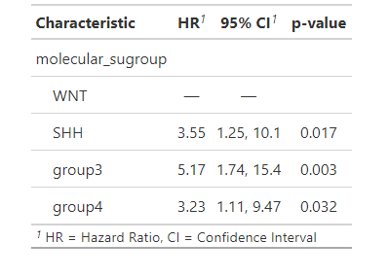



Here median is not achieved.



Here median for STR is 57

|  |  |  |  |
| --- | --- | --- | --- |
|  | Median | lower 95% CI | upper 95% CI |
| SHH\_STR | 57 | 55 | NA |



|  |  |  |  |
| --- | --- | --- | --- |
|  | Median | lower 95% CI | upper 95% CI |
| group3\_STR | 24 | 22 | NA |



Median is not reached.



|  |  |  |  |
| --- | --- | --- | --- |
|  | survival rate | lower 95% CI | upper 95% CI |
| PFS 3 year survival rate | 0.694 | 0.64 | 0.752 |
| PFS 5 year survival rate | 0.486 | 0.0359 | 0.562 |

|  |  |  |  |  |
| --- | --- | --- | --- | --- |
|  |  | survival rate | lower 95% CI | upper 95% CI |
| truncated fps 3 year survival rate | GTR+NTR | 0.7011 | 0.6407 | 0.7672 |
|  | STR | 0.6683 | 0.5582 | 0.8 |
| truncated fps 5 year survival rate | GTR+NTR | 0.4935 | 0.4206 | 0.5791 |
|  | STR | 0.458 | 0.3259 | 0.6435 |

**Hazard Ratio::**

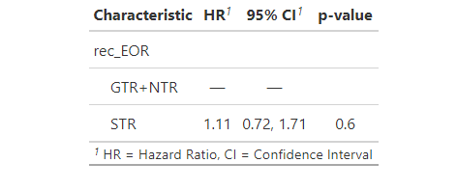

dd



|  |  |  |  |
| --- | --- | --- | --- |
|  | Median | lower 95% CI | upper 95% CI |
| molecular\_group4 | 52 | 25 | NA |

|  |  |  |  |  |
| --- | --- | --- | --- | --- |
|  |  | survival rate | lower 95% CI | upper 95% CI |
| truncated fps 3 year survival rate | WNT | 0.7962 | 0.6845 | 0.9261 |
|  | SHH | 0.7181 | 0.6343 | 0.813 |
|  | group3 | 0.5916 | 0.4633 | 0.7555 |
|  | group4 | 0.661 | 0.5611 | 0.7786 |
|  |  | survival rate | lower 95% CI | upper 95% CI |
| truncated fps 5 year survival rate | WNT | 0.754 | 0.627 | 0.907 |
|  | SHH | 0.4836 | 0.3828 | 0.611 |
|  | group3 | 0.465 | 0.322 | 0.671 |
|  | group4 | 0.3601 | 0.2524 | 0.514 |

The median is not achieved.

**Hazard Ratio Table:**

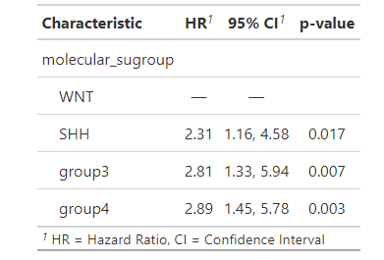



|  |  |  |  |
| --- | --- | --- | --- |
|  | Median | lower 95% CI | upper 95% CI |
| SHH\_STR | 51 | 36 | NA |



|  |  |  |  |
| --- | --- | --- | --- |
|  | Median | lower 95% CI | upper 95% CI |
| group3\_STR | 22 | 9 | NA |



|  |  |  |  |
| --- | --- | --- | --- |
|  | Median | lower 95% CI | upper 95% CI |
| group4\_GTR+NTR | 47 | 29 | NA |

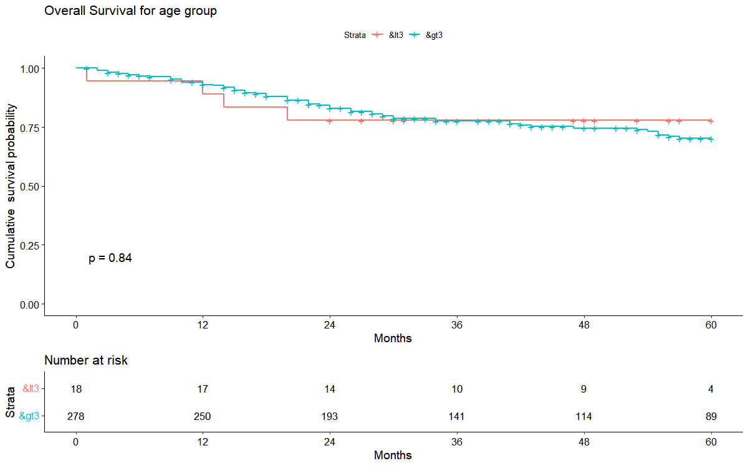

**The median is not reached.**

|  |  |  |  |  |
| --- | --- | --- | --- | --- |
|  |  | survival rate | lower 95% CI | upper 95% CI |
| truncatedOS 3 year survival rate | <3 | 0.778 | 0.608 | 0.996 |
|  | >3 | 0.7763 | 0.7253 | 0.831 |
| truncatedOS 5 year survival rate | <3 | 0.778 | 0.608 | 0.996 |
|  | >3 | 0.7023 | 0.6417 | 0.7688 |

**Hazard Ratio Table:**

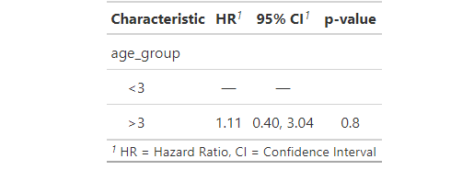

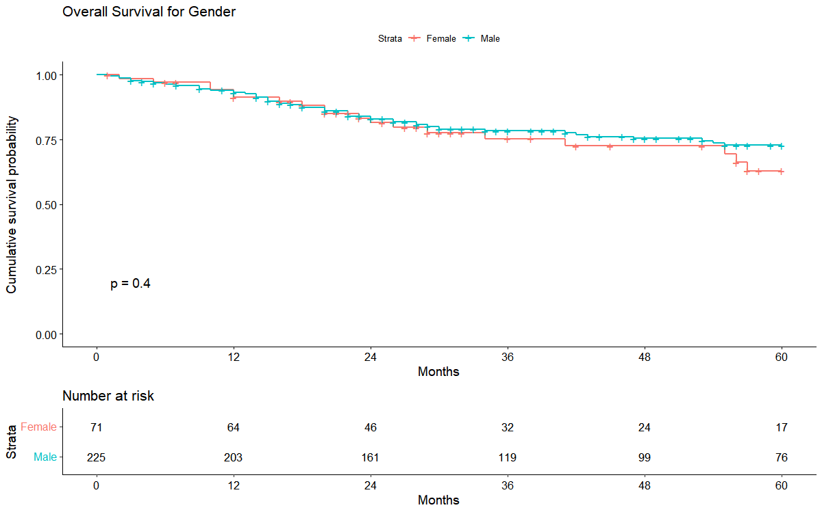

The median is not achieved.

|  |  |  |  |  |
| --- | --- | --- | --- | --- |
|  |  | survival rate | lower 95% CI | upper 95% CI |
| truncatedOS 3 year survival rate | Female | 0.7528 | 0.6495 | 0.8726 |
|  | Male | 0.7835 | 0.7283 | 0.8429 |
| truncatedOS 5 year survival rate | Female | 0.6297 | 0.5003 | 0.7925 |
|  | Male | 0.7288 | 0.6656 | 0.7981 |

**Hazard Ratio Table:**

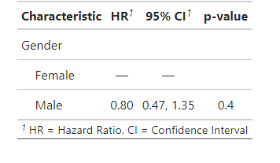

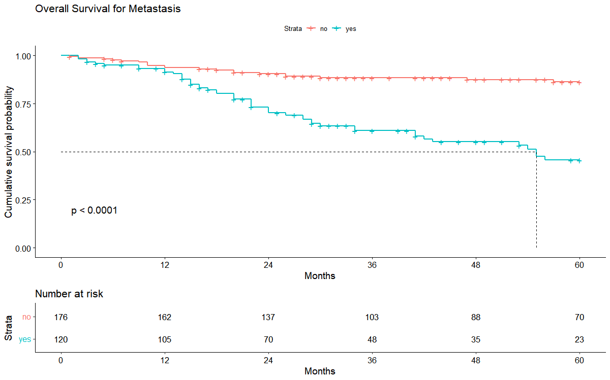

***Median:***

|  |  |  |  |
| --- | --- | --- | --- |
|  | Median | lower 95% CI | upper 95% CI |
| Metastasis\_yes | 55 | 41 | NA |

|  |  |  |  |  |
| --- | --- | --- | --- | --- |
|  |  | survival rate | lower 95% CI | upper 95% CI |
| truncatedOS 3 year survival rate | yes | 0.6097 | 0.5205 | 0.7143 |
|  | no | 0.8841 | 0.8361 | 0.9348 |
| truncatedOS 5 year survival rate | yes | 0.4565 | 0.3557 | 0.5858 |
|  | no | 0.8629 | 0.8085 | 0.921 |

**Hazard Ratio Table:**

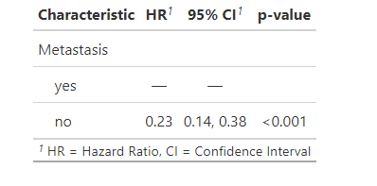

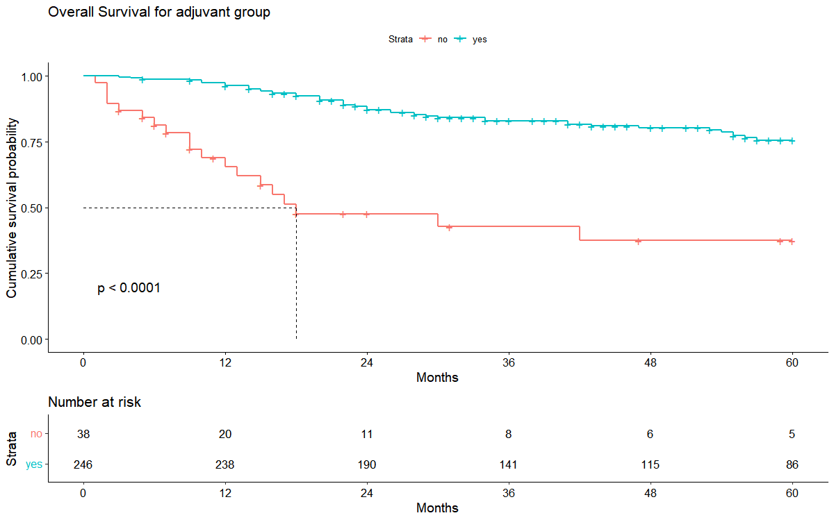

|  |  |  |  |
| --- | --- | --- | --- |
|  | Median | lower 95% CI | upper 95% CI |
| adjuv\_comp\_no | 18 | 13 | NA |

|  |  |  |  |  |
| --- | --- | --- | --- | --- |
|  |  | survival rate | lower 95% CI | upper 95% CI |
| truncatedOS 3 year survival rate | yes | 0.8303 | 0.7822 | 0.8815 |
|  | no | 0.428 | 0.2793 | 0.6561 |
| truncatedOS 5 year survival rate | yes | 0.7565 | 0.696 | 0.8222 |
|  | no | 0.3745 | 0.227 | 0.6181 |

**Hazard Ratio:**

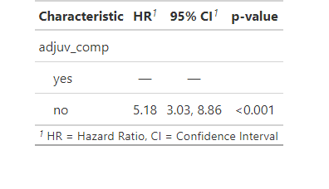

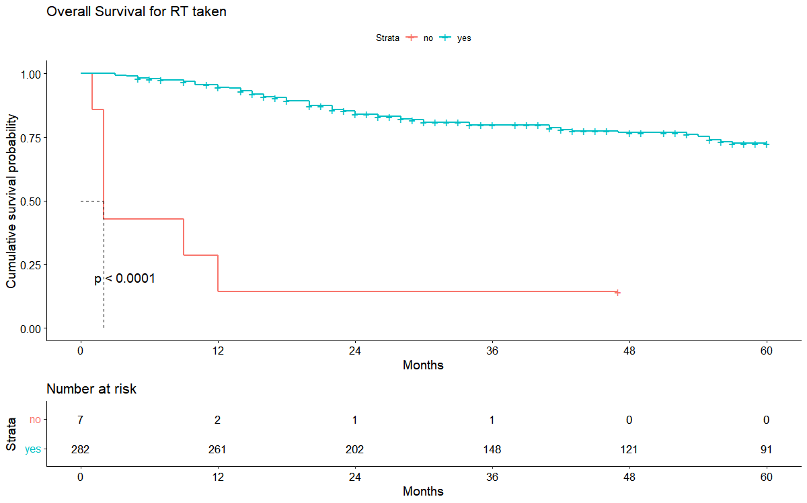

**Median:**

|  |  |  |  |
| --- | --- | --- | --- |
|  | Median | lower 95% CI | upper 95% CI |
| RT\_taken\_no | 2 | 2 | NA |

|  |  |  |  |  |
| --- | --- | --- | --- | --- |
|  |  | survival rate | lower 95% CI | upper 95% CI |
| truncatedOS 3 year survival rate | yes | 0.7981 | 0.7495 | 0.8498 |
|  | no | 0.1429 | 0.0233 | 0.8769 |
| truncatedOS 47 months survival rate | yes | 0.768 | 0.715 | 0.825 |
|  | no | 0.1429 | 0.0233 | 0.8769 |

**Hazard Ratio:**

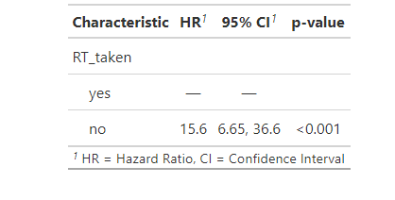

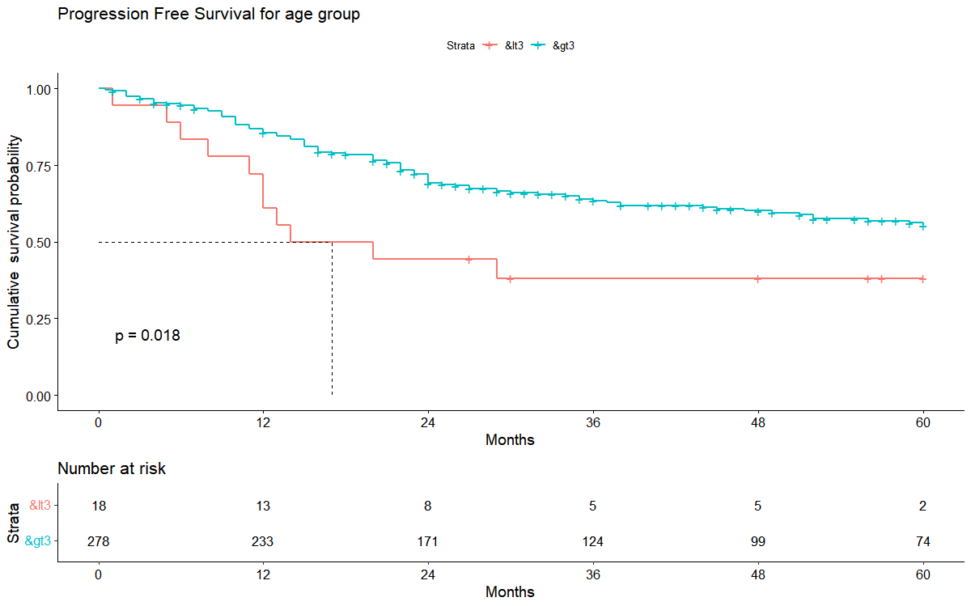

|  |  |  |  |
| --- | --- | --- | --- |
|  | Median | lower 95% CI | upper 95% CI |
| age group\_<3 | 17 | 12 | NA |

|  |  |  |  |  |
| --- | --- | --- | --- | --- |
|  |  | survival rate | lower 95% CI | upper 95% CI |
| truncatedOS 3 year survival rate | <3 | 0.381 | 0.209 | 0.693 |
|  | >3 | 0.635 | 0.5777 | 0.698 |
| Truncated\_pfs 5 years survival rate | <3 | 0.381 | 0.209 | 0.693 |
|  | >3 | 0.5538 | 0.4908 | 0.625 |

**Hazard Ratio:**

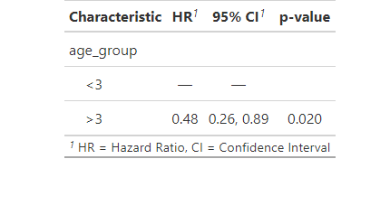

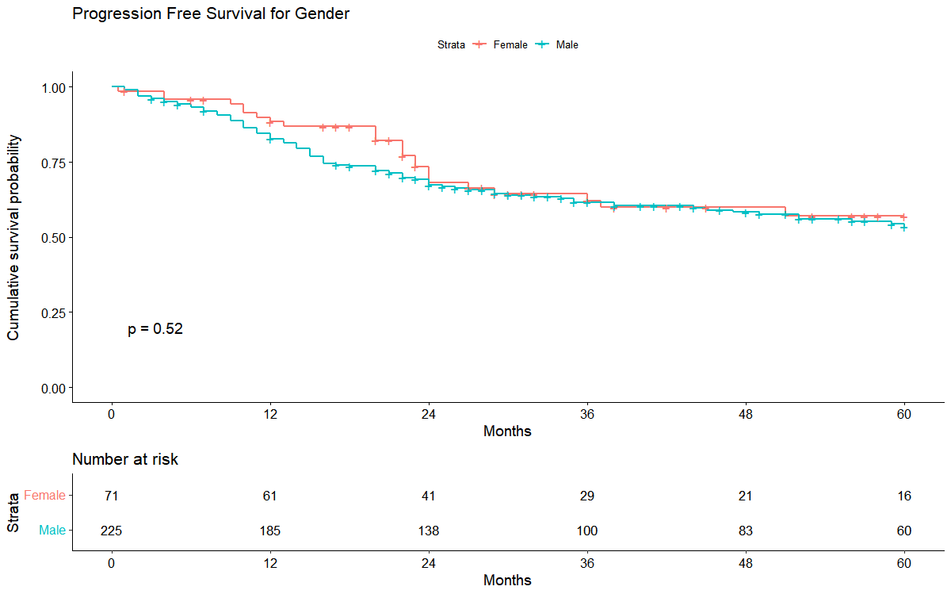

**The Median is not achieved.**

|  |  |  |  |  |
| --- | --- | --- | --- | --- |
|  |  | survival rate | lower 95% CI | upper 95% CI |
| Truncated\_pfs 3 year survival rate | Female | 0.6216 | 5085 | 0.7598 |
|  | Male | 0.6167 | 0.5538 | 0.6868 |
| Truncated\_pfs 4 years survival rate | Female | 0.5701 | 0.451 | 0.7206 |
|  | Male | 0.5346 | 0.4659 | 0.6134 |

**Hazard Ratio:**

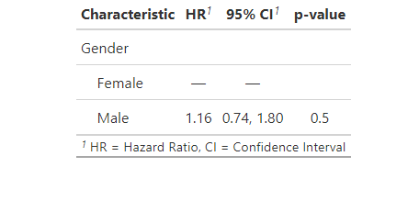

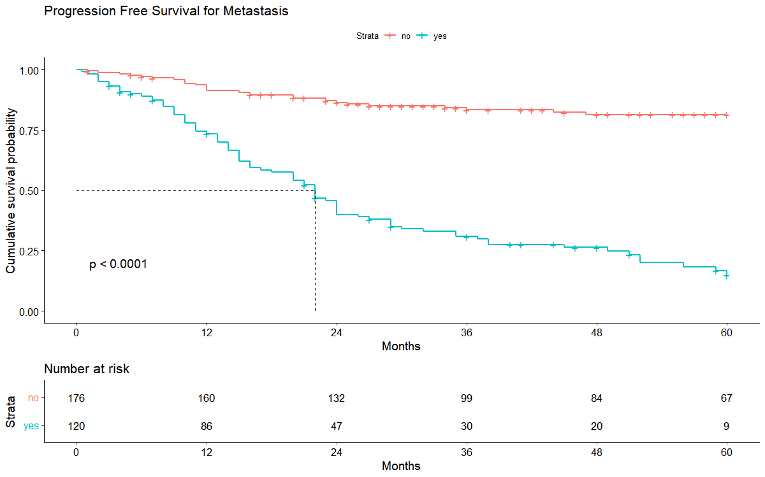

|  |  |  |  |
| --- | --- | --- | --- |
|  | Median | lower 95% CI | upper 95% CI |
| Metastasis\_Yes | 22 | 18 | NA |

|  |  |  |  |  |
| --- | --- | --- | --- | --- |
|  |  | survival rate | lower 95% CI | upper 95% CI |
| truncated\_pfs 3 year survival rate | yes | 0.3089 | 0.2325 | 0.4104 |
|  | no | 0.8334 | 0.7773 | 0.8935 |
| truncated\_pfs 5 years survival rate | yes | 0.1486 | 0.0863 | 0.2558 |
|  | no | 0.8141 | 0.7539 | 0.8791 |

**Hazard Ratio:**

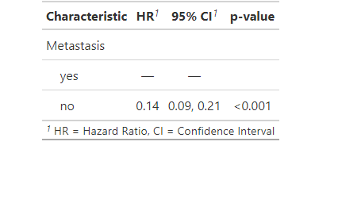

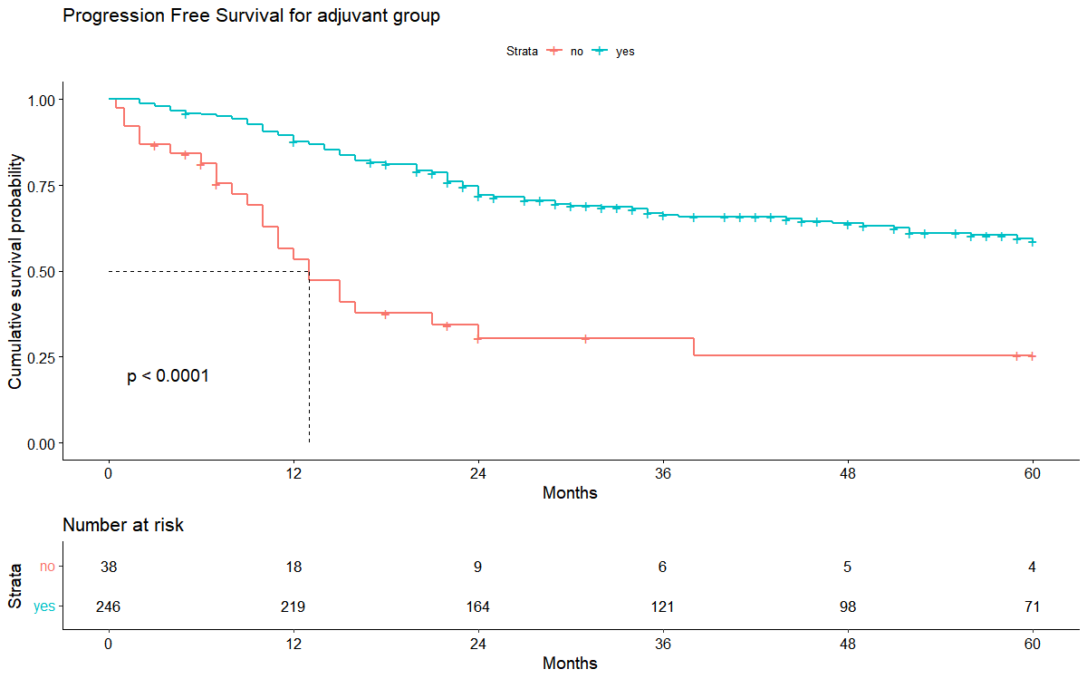

|  |  |  |  |
| --- | --- | --- | --- |
|  | Median | lower 95% CI | upper 95% CI |
| adjuvant\_no | 13 | 10 | 38 |

|  |  |  |  |  |
| --- | --- | --- | --- | --- |
|  |  | survival rate | lower 95% CI | upper 95% CI |
| truncated\_pfs 3 year survival rate | yes | 0.6639 | 0.605 | 0.7284 |
|  | no | 0.3051 | 0.1793 | 0.5191 |
| truncated\_pfs 5 years survival rate | yes | 0.5872 | 0.5217 | 0.6609 |
|  | no | 0.2543 | 0.134 | 0.4826 |

**Hazard Ratio:**

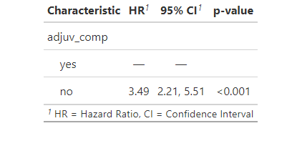

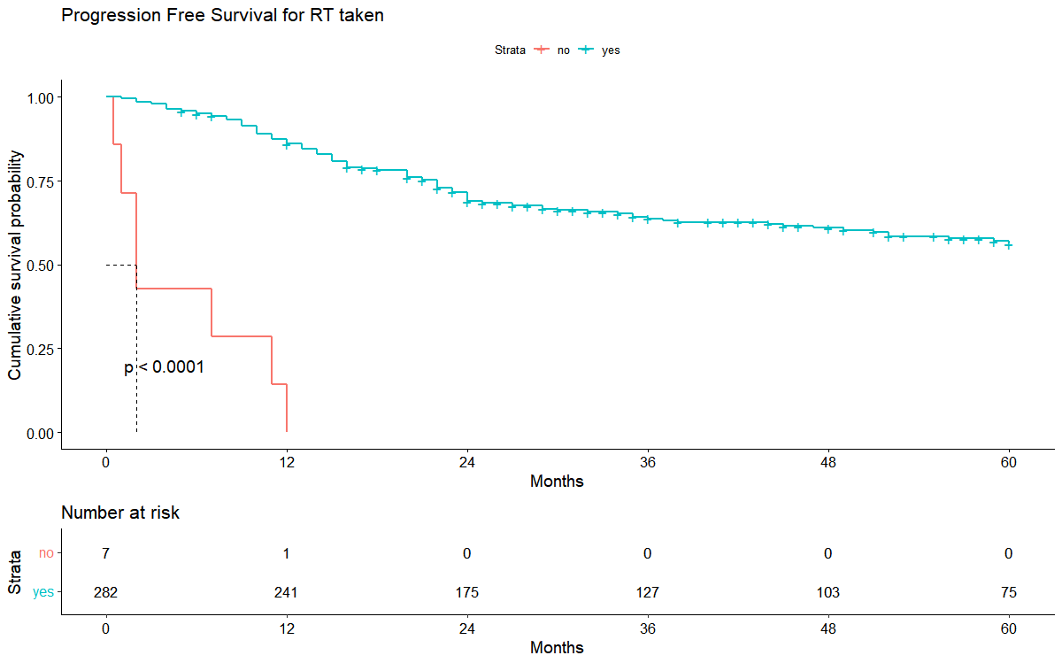

|  |  |  |  |
| --- | --- | --- | --- |
|  | Median | lower 95% CI | upper 95% CI |
| RT\_taken\_no | 2 | 1 | NA |

|  |  |  |  |  |
| --- | --- | --- | --- | --- |
|  |  | survival rate | lower 95% CI | upper 95% CI |
| truncated\_pfs 1 year survival rate | yes | 0.8596 | 0.8197 | 0.9015 |
|  | no | 0 | NA | NA |

**Hazard Ratio:**

